RESUME
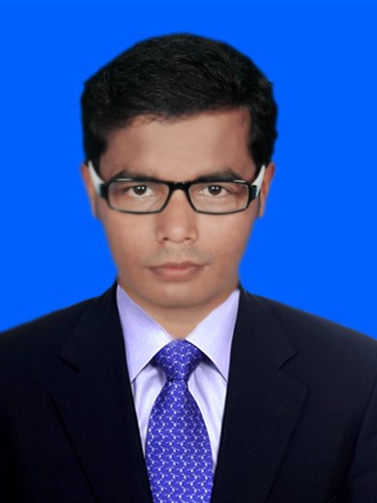
CHANDAN KUMAR GIRI
B.Ed, BCA
Plot no:-225,Gajapatinagar
Bhubaneswar
Pin code:- 751005 E.Mail:-chandangiri22@gmail.com
Mob:-+919778348125,8270665607
.

Career Objective:
To obtain a challenging position with a market leader that utilizes my experience in Administration & operation Sector.

Summary:
- Excellent interpersonal skills and great ability to interact with people at all level.
- Exceptionally self motivated with immense ability to work independently as well as in a team.
- Excellent spoken and written English, Hindi and Oriya skill.
- Experienced in providing oral and written presentations.
- Profoundly proficient in PC application (Excel, Word, PowerPoint, Net)
- Exceptional team player, constructive, responsive.
- Uncommon ability to work accurately and to tight deadline.

Professional Qualifications:

- Completed BCA from Utkal University in 2011.
- Continue B.Ed under Acharya Nagarjuna University(2016-18).

Academic Qualifications:

- +2 Sc. from S.R. College under CHSE, Odisha.
- Matriculation from S.C. High School under BSE, Odisha

Work Experience

- 5 Year teaching exp.as aprivate tuitior in math.

Computer skills:
Office Tools : MS Office (Word, Excel, Power Point)
Operating Systems : Windows-98/2000/XP, Vista,Windows-7.

Personal Information:
Father’s name: Mr. Amulya kumar giri
Date of Birth: 06th Apr 1991
Sex: Male
Marital Status: Single
Strength: Hard Working, Risk taker, Self Confidence
Interests: Listening to music, Playing Chess
Languages Known: English, Hindi and Oriya
.

Permanent Address:-
At:Kalikapur
Po:Baiganbadia
Via:Dahamunda
Dist:Balasore
Odisha
Pin-756079

Declaration:

I hereby declare that all the statements made herein are true and correct to the best of my knowledge and belief.

Date:25/03/2017 Signature
Place: Bhubaneswar

